**LAB ASSIGNMENT 8 – Due Sunday Noon**

ANSWER THE FOLLOWING QUESTIONS

1. Add an employee using your own name and create a project assignment for your self using existing project id.

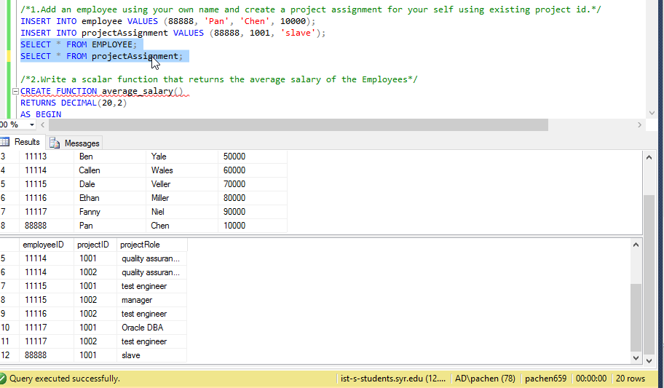

1. Write a scalar function that returns the average salary of the Employee

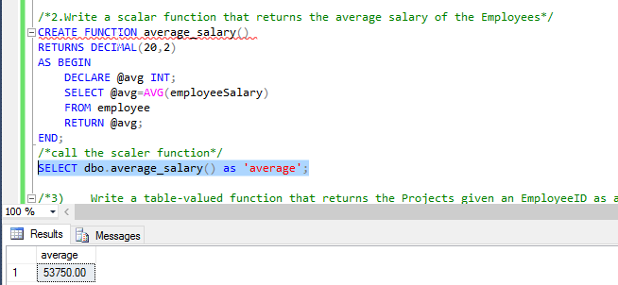

1. Write a table-valued function that returns the Projects given an EmployeeID as a parameter and
   1. Show the function created
   2. return the results for your own project

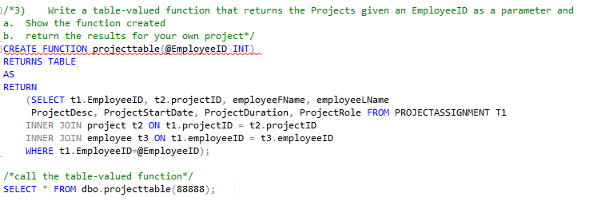

1. Alter the Employee table to add a new column called ‘Num of Projects’ which can be **INTEGER** data type. Write a procedure that updates employee table with the total projects assigned to each employee (to the newly created column)

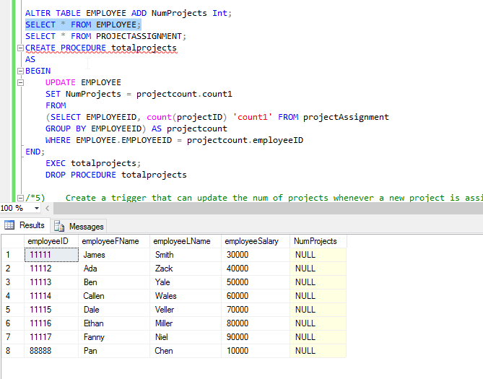

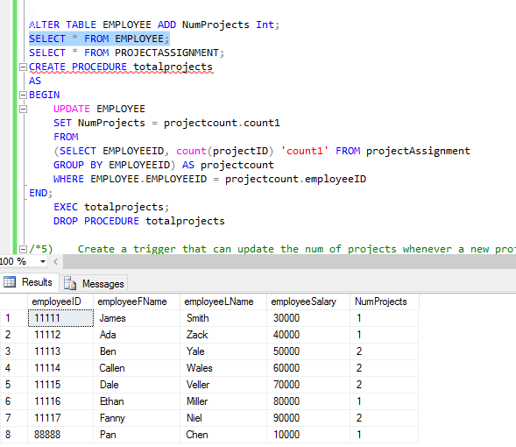

1. Create a trigger that can update the num of projects whenever a new project is assigned to an employee.

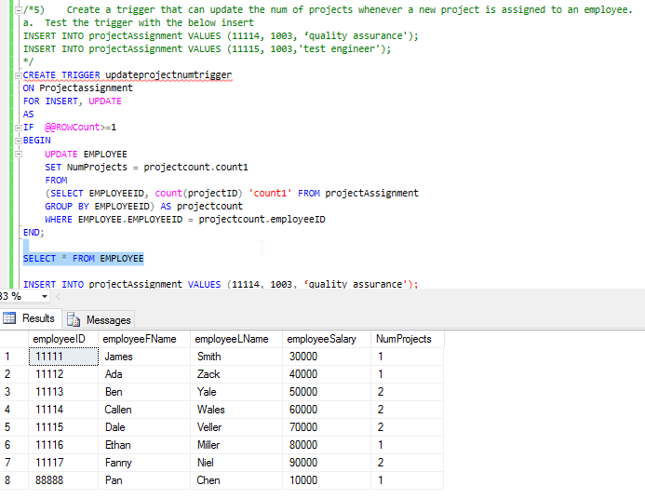

* 1. Test the trigger with the below insert

INSERT INTO projectAssignment VALUES (11114, 1003, ‘quality assurance');

INSERT INTO projectAssignment VALUES (11115, 1003,'test engineer');

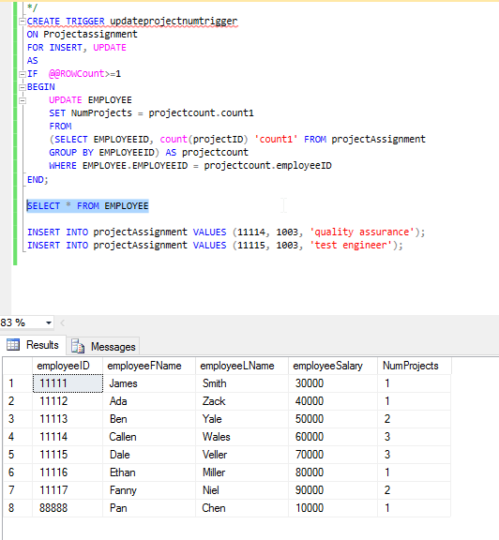

INSTRUCTIONS

* For each question, ensure that the screenshot of the function and procedure scripts and return value is also pasted in the document
* Make sure you paste the before and after screenshots for question 4. That is, the values for ‘No of Projects’ in Employee before and after execution of the procedure

*Please submit your lab report in one PDF file to BlackBoard. Name your file in this format “IST659-Lab8-Lastname-Firstname.pdf”.*